**Memory Layout**

1. **Factorial using Recursion.**

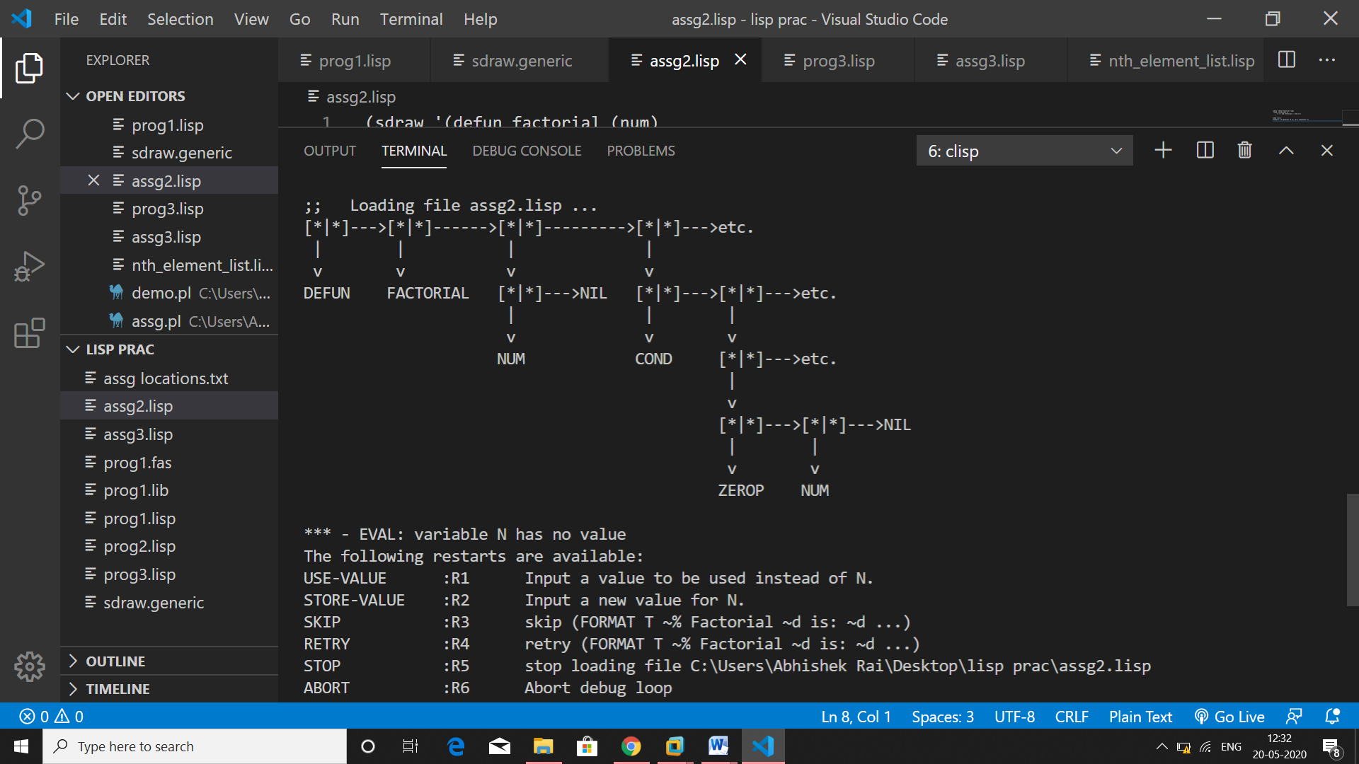

1. **Factorial using Iterative Method.**

